Chat Client User’s Guide

Contents
1. Introduction

2. Login

3. Functions

1. Introduction

Welcome to Chat Client – the game operator software to Chatting

About Chatting Client

- 4Story Client의 Chatting기능을 구현한 S/W
- 한대의 컴퓨터에 여러 개의 Chatting Client를 실행 가능함
- 실행 시 TChatClient.exe와 TItem.tcd File이 필요 함

2. Login

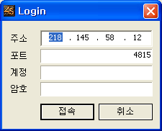

- Put in the Server IP Address / Port / Account Password
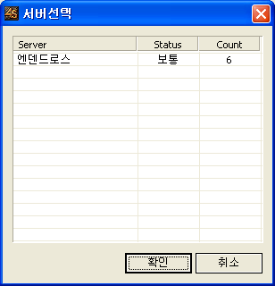
- Select the Server
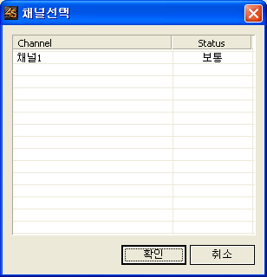
- Select Channel (Now Channel is One)

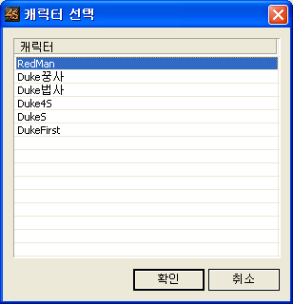
- Select the Character

3. Functions

- 서버 접속에 성공 후 관련 기능을 사용이 가능하다

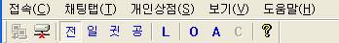

Menu | Item | Explain | Comment
Connect | Login | Login the Server
Connect | Logout | Logout the Server
Chatting Tab | All | Send message to all user
Chatting Tab | Normal | Send message to neighborhood
Chatting Tab | Whisper | Send message to target user
Chatting Tab | Notice | Send Notice Message
Personal Shop | Shop Open | Open the personal shop
Personal Shop | Shop Close | Close the personal shop
Personal Shop | Auto Shop

